NAME: K.Mounith
REG NO: 192425090
COURSE : ITA0515 - COMPUTER VISION
SLOT : B

Aim:To read an image in Python and perform erosion using the OpenCV erode() function.
Algorithm
- Import OpenCV and NumPy libraries.
- Read the input image.
- Create a kernel matrix.
- Apply cv2.erode() to the image.
- Display the original and eroded images.
CODE:
import cv2 import numpy as np from google.colab.patches import cv2_imshow img = cv2.imread(r"/content/images.png") kernel=np.ones((5,5),np.uint8) erode=cv2.erode(img,kernel,iterations=1) cv2_imshow(img) cv2_imshow(erode)
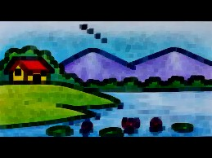

Result
The image was successfully read and erosion was performed. Small white regions were removed, and the object boundaries became thinner.

Aim
To read a captured video and display it in slow motion and fast motion using OpenCV.
Algorithm
- Import OpenCV.
- Open the video using VideoCapture().
- Read each frame.
- Display the frames with different delay times using waitKey().
- Close the video after completion.
CODE:
import cv2 from google.colab.patches import cv2_imshow path = r"/content/istockphoto-2155009603-640_adpp_is.mp4" def play_video(delay, title):
cap = cv2.VideoCapture(path) print(title + " - Press q to continue") while True:
ret, frame = cap.read() if not ret: break
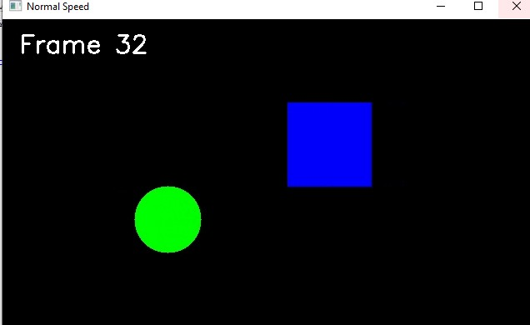
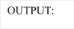
cv2_imshow(frame) if cv2.waitKey(delay) & 0xFF == ord('q'):
break cap.release()
# Call function for different speeds play_video(30, "Normal Speed") play_video(100, "Slow Motion") play_video(10, "Fast Motion")
RESULT- The program is executed successfully.

Aim
To capture video from a webcam and display it in slow motion and fast motion.
Algorithm
- Import OpenCV.
- Access the webcam using VideoCapture(0).
- Capture video frames continuously.
- Display frames using different delay values.
- Exit when a key is pressed.
CODE:
import cv2 from google.colab.patches import cv2_imshow path = r"/content/istockphoto-2155009603-640_adpp_is.mp4" def play_video(delay, title):
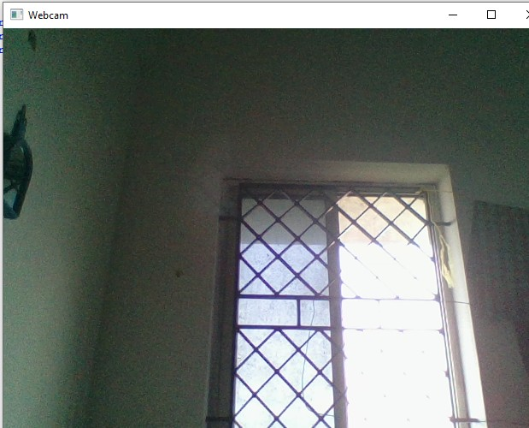
cap = cv2.VideoCapture(path) print(title + " - Press q to continue") while True:
ret, frame = cap.read() if not ret: break
cv2_imshow(frame) if cv2.waitKey(delay) & 0xFF == ord('q'):
break
play_video(30, "Normal Speed") play_video(100, "Slow Motion") play_video(10, "Fast Motion")

RESULT- The program is executed successfully.

EXPERIMENT-8

scale into bigger and smaller sizes using OpenCV.
- input image.
- Use cv2.resize() with scale factors.
- Create enlarged and reduced images.
- Display all images.
CODE:
import cv2 from google.colab.patches import cv2_imshow Upload the image to Colab first image = cv2.imread("/content/images.png") if image is None:
print("Image not found!") else:
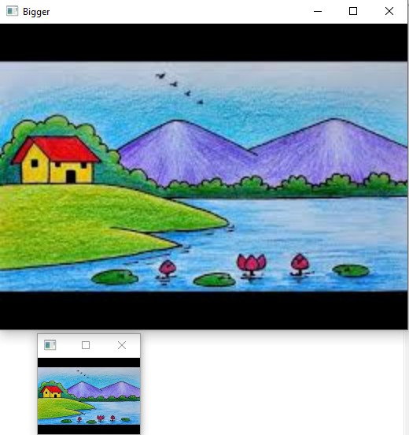
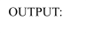
bigger = cv2.resize(image, None, fx=2, fy=2) smaller = cv2.resize(image, None, fx=0.5, fy=0.5) print("Original Image") cv2_imshow(image) print("Bigger Image") cv2_imshow(bigger) print("Smaller Image") cv2_imshow(smaller)

RESULT- The program is executed successfully.

EXPERIMENT-9
rotate in clockwise and counter-clockwise directions.
- image.
- Use cv2.rotate() for clockwise rotation.
- Use cv2.rotate() for counter-clockwise rotation.
- Display the rotated images.
CODE:
import cv2 from google.colab.patches import cv2_imshow image = cv2.imread("/content/images.png") if image is None:
print("Image not found!") else:
clockwise = cv2.rotate(image, cv2.ROTATE_90_CLOCKWISE) counter_clockwise = cv2.rotate(image, cv2.ROTATE_90_COUNTERCLOCKWISE)
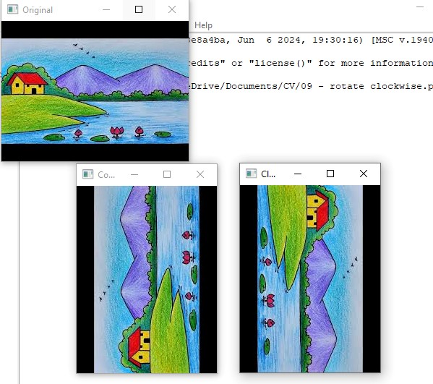
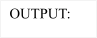
print("Original Image") cv2_imshow(image) print("Clockwise Rotation") cv2_imshow(clockwise) print("Counter-Clockwise Rotation") cv2_imshow(counter_clockwise)

RESULT- The program is executed successfully.

EXPERIMENT-10
move from one position to another using translation.
- image.
- Create a translation matrix.
- Apply cv2.warpAffine().
- Display the translated image.
CODE:
import cv2 import numpy as np from google.colab import files from google.colab.patches import cv2_imshow uploaded = files.upload() image = cv2.imread("sample.jpg") rows, cols = image.shape[:2]
M = np.float32([[1,0,100],
[0,1,50]])

move = cv2.warpAffine(image, M, (cols, rows)) print("Original")
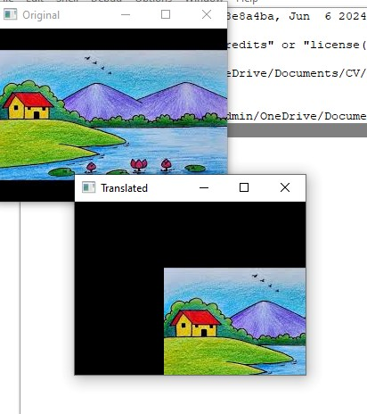
cv2_imshow(image) print("Moved") cv2_imshow(move)

RESULT- The program is executed successfully.

EXPERIMENT-11

affine transformation on an image using OpenCV.
the image.
Select three source points.
- Select three destination points.
- Compute the affine transformation matrix.
- Apply cv2.warpAffine().
- Display the transformed image.
CODE:
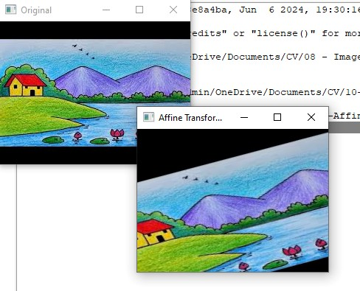

import cv2 import numpy as np from google.colab import files from google.colab.patches import cv2_imshow uploaded = files.upload() image = cv2.imread("sample.jpg") rows, cols = image.shape[:2] pts1 = np.float32([[50,50],[200,50],[50,200]]) pts2 = np.float32([[10,100],[200,50],[100,250]]) M = cv2.getAffineTransform(pts1, pts2) affine = cv2.warpAffine(image, M, (cols, rows)) print("Original") cv2_imshow(image)
print("Affine") cv2_imshow(affine)

RESULT- The program is executed successfully.

EXPERIMENT-12
perspective transformation on an image using OpenCV.
the input image.
Select four source points.
- Select four destination points.
- Compute the perspective transformation matrix.
- Apply cv2.warpPerspective().
- Display the transformed image.
CODE:
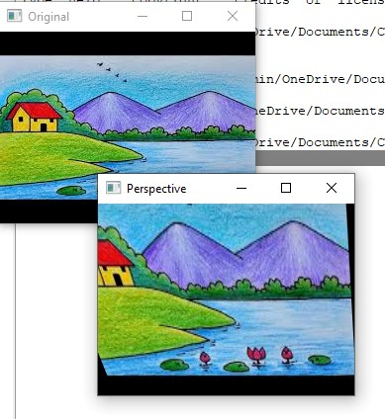

import cv2 import numpy as np from google.colab import files from google.colab.patches import cv2_imshow uploaded = files.upload() image = cv2.imread("sample.jpg") rows, cols = image.shape[:2] pts1 = np.float32([[50,50],[300,50],[50,300],[300,300]]) pts2 = np.float32([[10,100],[300,50],[100,250],[280,300]]) M = cv2.getPerspectiveTransform(pts1, pts2)
perspective = cv2.warpPerspective(image, M, (cols, rows)) print("Original") cv2_imshow(image) print("Perspective") cv2_imshow(perspective)

RESULT- The program is executed successfully.

EXPERIMENT-13
perspective transformation on a video using OpenCV.
the video.
Capture each video frame.
- Define source and destination points.
- Compute the perspective transformation matrix.
- Apply cv2.warpPerspective() to each frame.
- Display the transformed video.
CODE:
import cv2 import numpy as np cap = cv2.VideoCapture(r"C:\Users\admin\Downloads\sample_video.mp4") if not cap.isOpened():
print("Error: Cannot open video file.")
exit()
while True:
ret, frame = cap.read() if not ret:
print("Video Finished") break h, w = frame.shape[:2] pts1 = np.float32([
[50, 50],
[w - 50, 50],
[50, h - 50],
[w - 50, h - 50]
])
pts2 = np.float32([
[0, 0],

[w, 0],
[100, h],
[w - 100, h]
])
M = cv2.getPerspectiveTransform(pts1, pts2) output = cv2.warpPerspective(frame, M, (w, h)) cv2.imshow("Original Video", frame) cv2.imshow("Perspective Transformation", output) if cv2.waitKey(30) & 0xFF == ord('q'):
break

cap.release() cv2.destroyAllWindows()

OUTPUT:
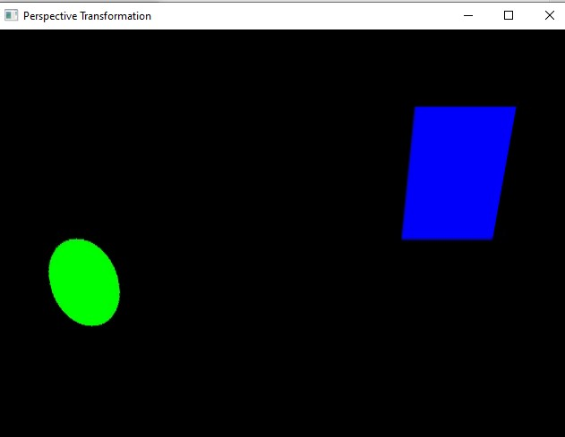

RESULT- The program is executed successfully.

EXPERIMENT - 14
Aim
To perform image transformation using a Homography matrix in OpenCV.
Algorithm
- Read the input image.
- Select source and destination points.
- Compute the Homography matrix.
- Apply the transformation using warpPerspective().
- Display the transformed image.
CODE:
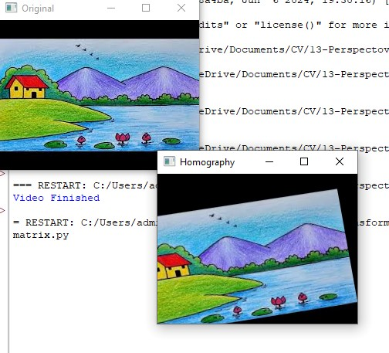
import cv2 import numpy as np img = cv2.imread(r"C:\Users\admin\Downloads\image.jfif") rows, cols = img.shape[:2] src = np.float32([[50,50], [300,50], [50,300], [300,300]]) dst = np.float32([[20,80], [280,40], [80,320], [320,280]]) H, status = cv2.findHomography(src, dst) result = cv2.warpPerspective(img, H, (cols, rows)) cv2.imshow("Original", img) cv2.imshow("Homography", result) cv2.waitKey(0) cv2.destroyAllWindows()

RESULT- The program is executed successfully.

EXPERIMENT - 15
Aim
To perform image transformation using the Direct Linear Transformation (DLT) method in OpenCV.
Algorithm
- Read the input image.
- Define the source and destination points.
- Compute the transformation matrix using the DLT method.
- Apply the perspective transformation.
- Display the transformed image.
CODE:
import cv2 import numpy as np img = cv2.imread(r"C:\Users\admin\Downloads\image.jfif") rows, cols = img.shape[:2] src = np.float32([[50,50], [300,50], [50,300], [300,300]]) dst = np.float32([[20,80], [280,40], [80,320], [320,280]])
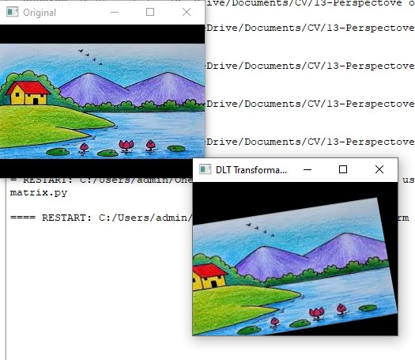
# DLT is internally used by OpenCV to compute the homography H = cv2.getPerspectiveTransform(src, dst) result = cv2.warpPerspective(img, H, (cols, rows)) cv2.imshow("Original", img) cv2.imshow("DLT Transformation", result) cv2.waitKey(0) cv2.destroyAllWindows()

RESULT- The program is executed successfully

